

**Degree:** BSc (Honours) Software Engineering

**Stage:** 3

**Batch:** 14.2 (Batch 3)

**Supervisor:**  Mr. Udesh Amarasinghe

**THE**

**FORE RUNNERS**

Believe everything is possible

**INDEX NUMBER FULL NAME**

10541973 Basura Ratnayake

Gruha Pathi 1.0 - A new frontier in HOME Automation

Interim Report Two

Table of Contents

Tasks Undertaken and Outcomes 1

Products Produced and Product Quality 2

Hardware Components 2

Software Components 3

System Diagram 5

Risks that have Materialized and Solutions 6

Schedule 6

Resources 7

Learning Undertaken 7

A DraftTOC of Final Project Report 8

Background and Research 9

Domain Research 9

Problem Identification 9

Extent in Determining the Scope 9

Technical Research 10

Analysis of Researched Solutions 10

Evaluating the Problem Scope 10

# Tasks Undertaken and Outcomes

1. Development of Control Hub

The Control Hub controls the devices in the house using RF 433 MHz frequency and manages data transmission between web server and the devices. Acquired the required electronic components and the construction is almost 5% completed.

1. Development of Door and Window Controller

This device open and close a window/door according to inputs from the Control Hub. The construction is almost 40% completed.

1. Development of Water Tap Device

This device controls the flow of water and also retain its usage and transmit to the Control Hub. Construction is about 50% completed.

1. Development of Mobile Application

The construction is almost 20% completed.

1. Development of Database

The database is built using MySQL and will be hosted on the web server. The construction is almost 90% completed.

1. Development of Web Server API

Started work on the API to support the Control Hub, Mobile and Desktop application data transmissions and will be hosted on a shared hosting site. The construction is 10% completed.

# Products Produced and Product Quality

## Hardware Components

**Light Device and Power Outlet Device.**

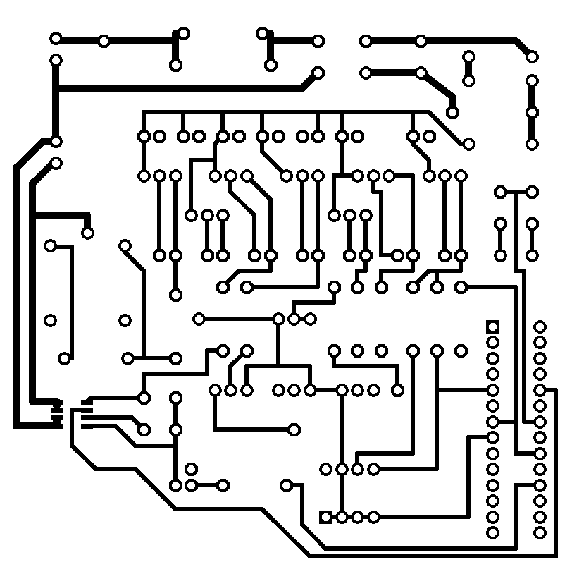

Made Printed Circuit Boards(PCB) for the devices by printing them onto copper boards and using Ferric Chloride to remove excess copper. Then soldered the electronic components onto the PCBs *(Refer Figure 2 & 3)*.

I used Cad Soft Eagle to design the PCB design and a 60W soldering iron for PCB soldering. The circuit was kept powered up for 24hrs to test its performance and durability.

Figure 1: Printed PCB on Paper

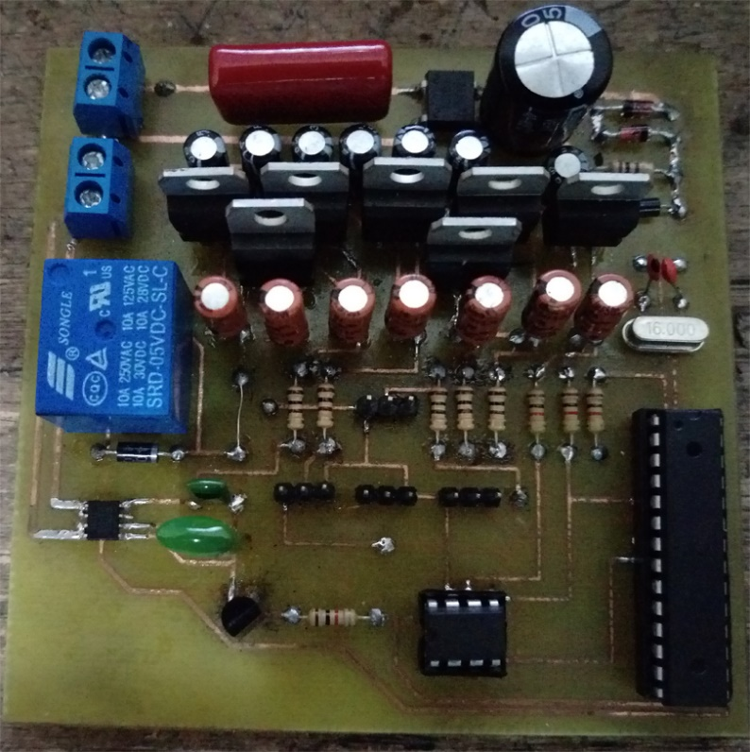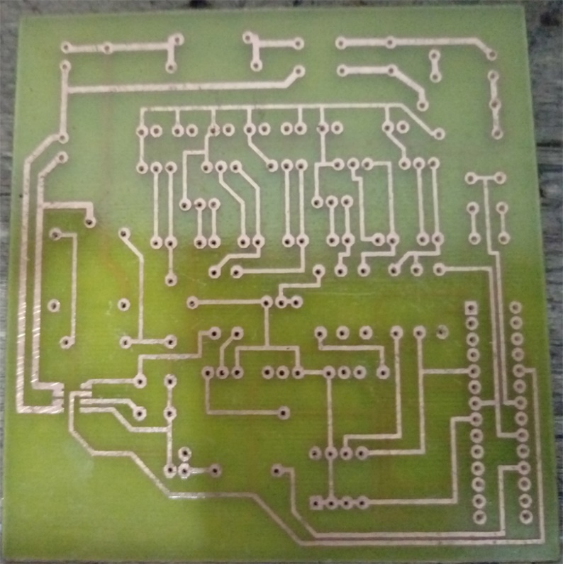

Figure 2: Printed PCB

Figure 3: Printed PCB with Components Soldered

The PCB uses a 433mhz transmitter and a receiver for communication and a PIR sensor to detect movement to decide whether to switch ON/OFF device.

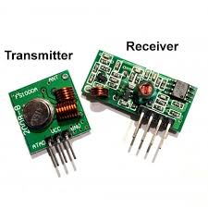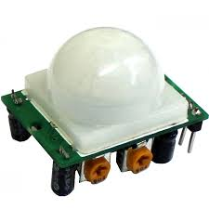

Figure 5: 433Mhz Transmitter and Receiver

Figure 4: PIR Sensor

## Software Components

**Desktop Application**

Managed to create all GUIs of the desktop application suitable for integration with the web server. This application can control all aspects of the house connected with the system.

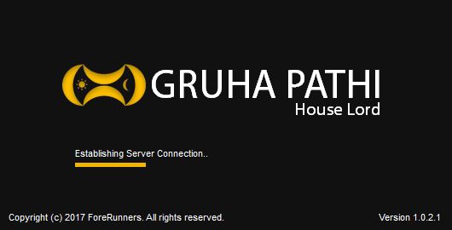 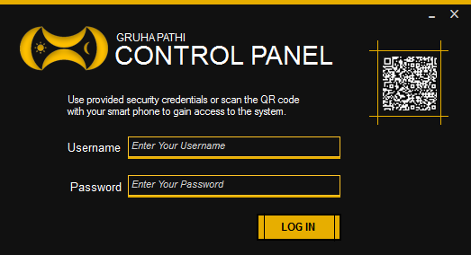 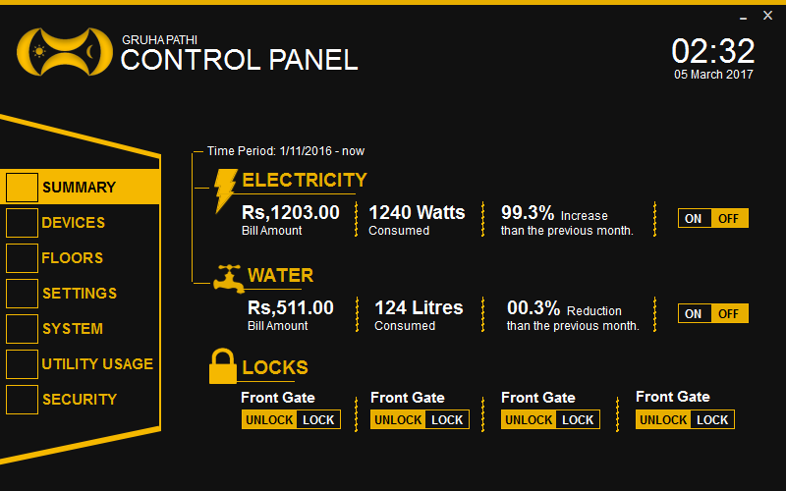 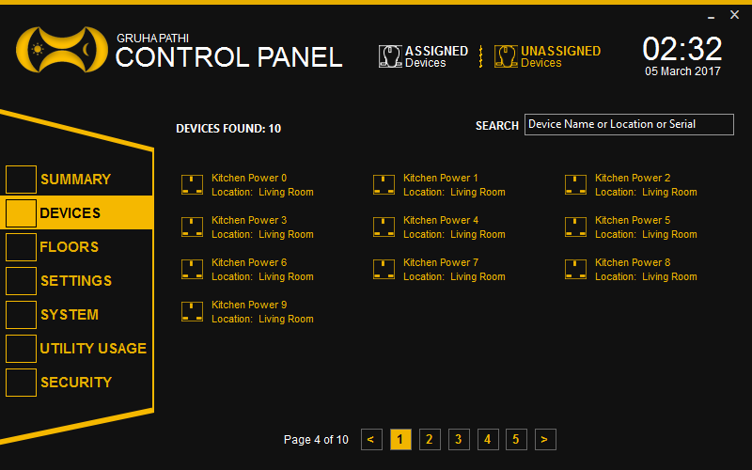 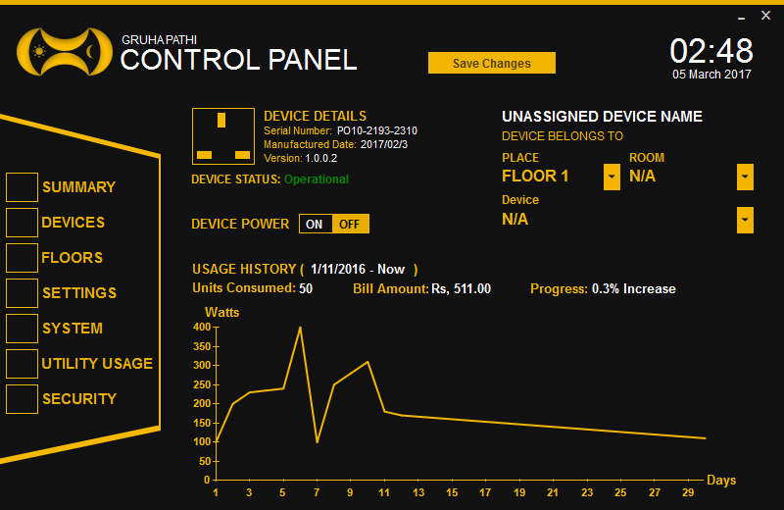 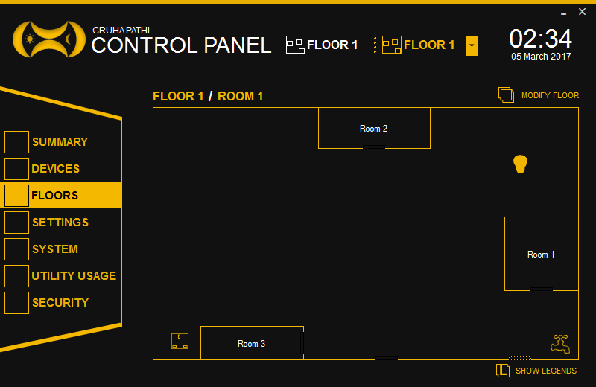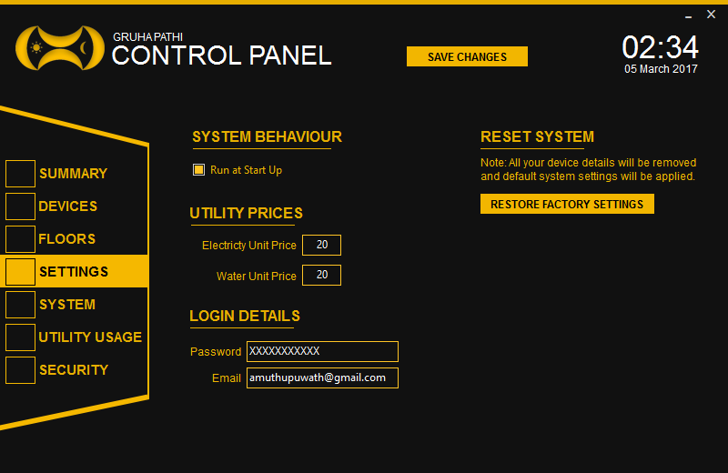 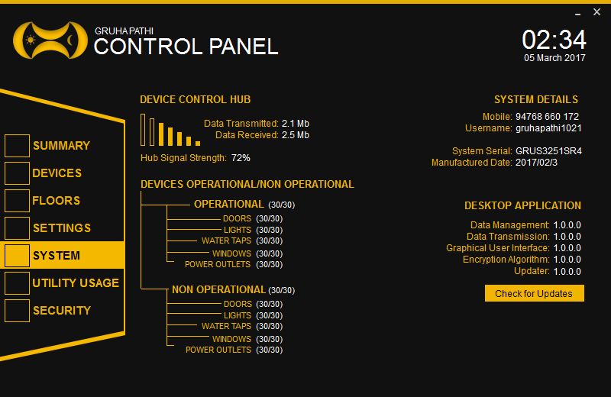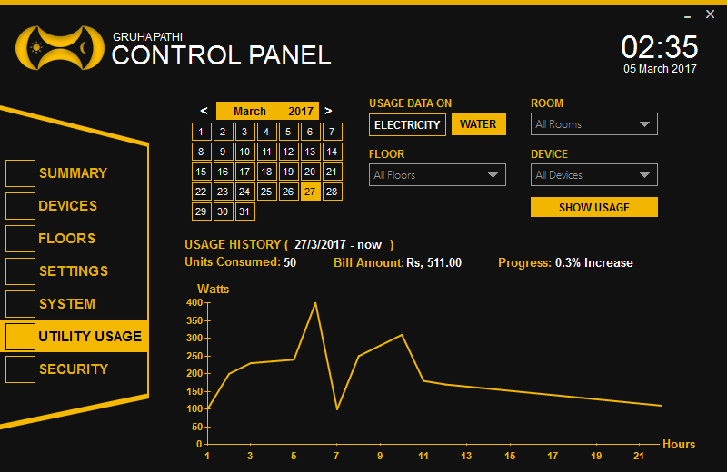 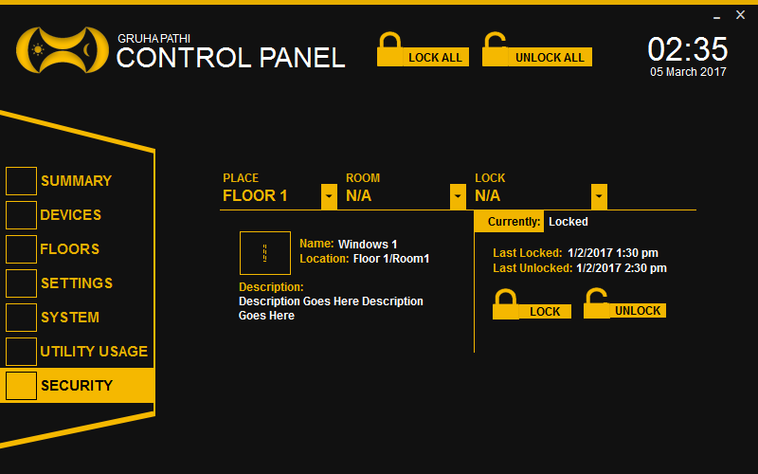

**Mobile Application**

Managed to create all GUIs of the mobile application suitable for integration with the web server. The mobile application has partial functionality when compared with the desktop, this is used mainly to receive notifications and grant user the access to the desktop system.

The application is currently designed for android smartphones but can be extended for other platforms if desired.

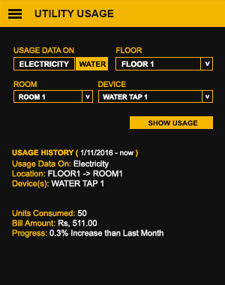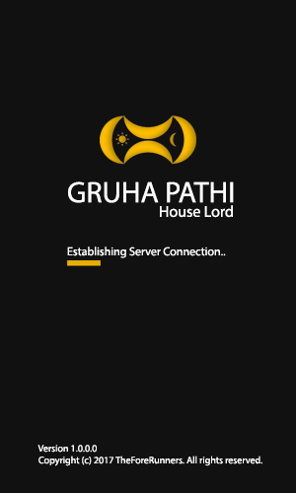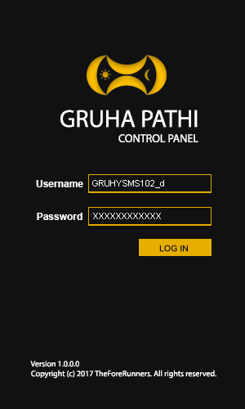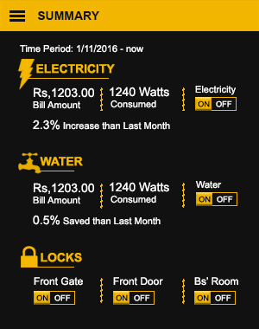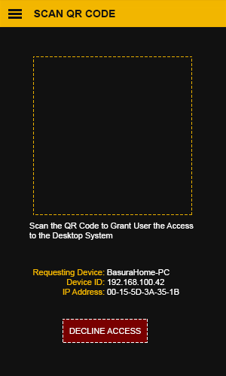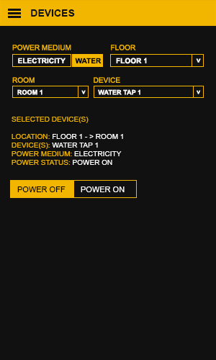

## System Diagram

The system receives commands from the web server to the Gruha Pathi Control Hub through the Home Router, this uses LAN based internet. All the other devices use 433 MHz frequency for commands and data transferences, this in turn doesn’t waste the home internet unnecessarily.

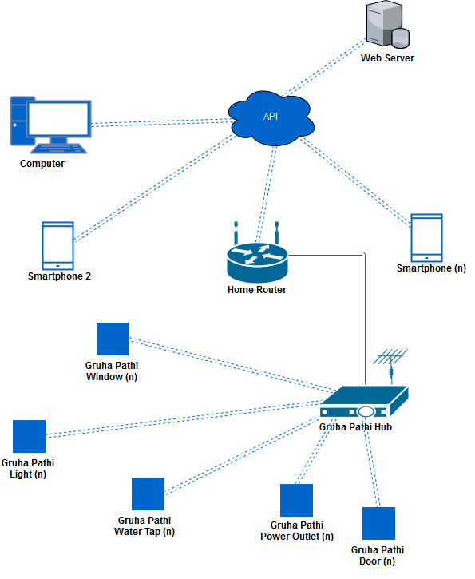

# Risks that have Materialized and Solutions

1. **Limited Time**

I am currently enrolled in an internship at a company so it’s a but complicated to stick to the schedule that I have formulated for the successful completion of the project and I will try to stick to the schedule as much as possible.

1. **Lack of Electrical and Electronic Advanced Concepts**

I have to practically demonstrate the electrical and electronic concepts which are new to me in order to build my circuits. I have done tremendous amount of research and self-learning on YouTube/Linda in order to learn the concepts of building circuits. I could have bought prebuilt circuits but I decided to build them on my own because most of the prebuilt circuits are not suited for my tasks.

1. **Lack of Resources**

I planned the project budget to be around Rs. 10,000 but with the increasing amount of prices of components it had to be increased to Rs. 20, 000. The money spent on this project are solely from my internship salary and I haven’t borrowed a single dime from a third party including my parents because I wanted to do this completely on my own.

1. **Building the Mobile Application**

Native android application development is a bit complicated but I will try to overcome that and build a good look, working mobile application.

# Schedule

On Schedule Little Off Schedule Failed to Complete Not Started

|  |  |  |  |  |  |  |  |  |  |  |  |  |
| --- | --- | --- | --- | --- | --- | --- | --- | --- | --- | --- | --- | --- |
| Stage | October | November | | December | | January | | February | | March | | April |
| One |  |  |  | |  | |  | |  | |  | |
| Two |  |  |  | |  | |  | |  | |  | |
| Three |  |  |  | |  | |  | |  | |  | |
| Four |  |  |  | |  | |  | |  | |  | |
| Five |  |  |  | |  | |  | |  | |  | |

# Resources

Project capital of Rs. 10,000 had to be increased to 20, 000. As of now 60% of the capital was spent purchasing electrical, electronic components and etc. The following items were purchased,

Hardware

* Electrolytic and Ceramic Capacitors (1nf – 1000uf)
* Resistors (100ohms – 1mega ohm)
* Transistors (PN2222A, TIP120, BD140)
* Integrated Circuits (ATMEGA328-PU, LM7805, LM7812, ACS712, 24C64, NE555)
* Sensors (PIR, IR)
* Others (Servo, Motor Shield, Water Flow Detector, Arduino Uno, LAN Shield, WIFI Shield, 433mhz Transmitter, 433mhz Receiver, etc.)
* Double Sided Copper Plates
* Ferric Chloride
* Soldering Iron and Solder
* PCB Drill

Software

* CADSOFT Eagle
* Web Server (Need to Purchase)

# Learning Undertaken

* Micro-Controller Programming

Learned Arduino based programming and to operate sensors connected to Arduino

* Electrical and Electronic Theories

Learned the basics of electronics in order to create schematics and circuits from schematics.

* Smartphone Application Development

Gained the basic knowledge to create a smartphone application using Android Studio, Phone Gap and Ionic Framework.

* PCB Building

Watched video tutorials on how to build commercial PCBs using fabrication with great difficult managed to build a good looking PCB.

# A DraftTOC of Final Project Report

1. Abstract
2. Acknowledgement
3. Declaration
4. Introduction
5. Background and Research
   1. Domain Research
      1. Problem Identification
      2. Extent in Determining the Scope
   2. Technical Research
      1. Analysis of Research Technologies
      2. Evaluating the Problem Scope
6. Business Case
7. Project Objectives
   1. Functional Requirements
   2. Non-Functional Requirements
   3. Usability Requirements
   4. Development Requirements
8. Scope of the Project
9. Design
   1. Use Case Diagram
   2. Activity Diagram
   3. Class Diagram
10. UI and UX design
11. Use of Human Computer Interaction (HCI)
12. User Documentation
    1. Functionality/ User Manual
    2. Supporting platforms
13. Known Bugs
14. Desired improvements
15. Conclusion
16. Bibliography
17. Appendices
    1. Supervisor meetings
    2. Project initiation document
    3. Interim reports

The below mentioned research are draft chapters from the final year project.

# Background and Research

## Domain Research

### Problem Identification

The basic premise of the initial project problem gets defined by evaluating its scope. In the present, the busy life style of an employed individual or a family doesn’t allow them the necessary time to take care of a house or an apartment. This in return results in,

* Electrical equipment not turned off while not using. For an example lights not turned off in the morning, Fans switched On when no one is around and etc.
* Water taps not properly closed.
* House doors and windows not properly closed at night.

When an equipment is not properly used it gets damaged and the same can be said about a house. When things are not properly taken care of, the house owners have to incur a tremendous amount of wealth every month to just to fix the broken things and pay the pay the bills on wastage. More importantly if a burglar happened to enter the premises at night through an improperly closed door or window not only the wealth is in danger but also the lives of the people living inside is also at jeopardy.

### Extent in Determining the Scope

Time is a precious commodity that must not be wasted on tasks that can be automated therefore instead of manually manipulating appliances and determining the usage of those appliance, it is better to be informed by an automatic system that can perform almost all of the tasks performed manually.

For this scenario, the targeted implementation should address to manage the resources and increase efficiency in a potential house by-

* Measures the electrical and water usage from each appliance and then calculate the total usage in order to generate a near approximate payable amount at the end of the month.
* Ability to set a limit in electrical and water usage.
* Ability to control the appliances remotely and let system turn off devices when no one is around.
* Ability to use alternate power systems for electricity appliances in case of a power failure.
* Automatic door and window locking at night and activate security to features to protect against threats.

## Technical Research

### Analysis of Researched Solutions

There are many home automation systems in the world but I focused directly on home automation systems available in Sri Lanka because my implementation will be specifically for Sri Lanka users.

1. **Dialog Smart Home**

Lacks a complete functional system and use independent gadgets from Movinta Group. These components are by far the most advanced devices related to home automation available in Sri Lanka. They use both Bluetooth and an internet connection to command their devices through an android application.

1. **NOSTERS Automation System**

NOSTERS provide commercial applications for industrial complexes and no home automation systems available as of yet. These systems, they provide are all hard-coded systems that are specifically designed for a single complex and the users cannot make any modifications to systems. All modifications have to be made by re-designing the entire system and they consume a huge amount of bandwidth when sending and receiving commands (Cinnamon Grand Hotel, 2008).

1. **HomeTEC Lanka**

They provide no integrated systems, only isolated components that require individual input mechanisms meaning each device has to have a separate input device. They use RF communications to send and receive commands and doesn’t intrude or disrupt the internet bandwidth.

1. **Southern Automation Systems**

They provide custom user specified systems or components but none of the devices are developed by them all of the devices are imported from Danfoss, Satchwell, Frascold, Novus Edge and Tridium. The use extensive amount of internet bandwidth which sometimes disrupt the internet connection.

### Evaluating the Problem Scope

1. Exploring different types of available home automation systems according to the problem parameters, it’s clear from already available research that only through combining multiple types of advantageous features of those system and inventing new features is the most optimal solution be implemented. To this end, understanding and researching about these heuristics had to be done.
2. An array of devices has to be designed to manipulate the workings of the house allowing the system and the users to-
   1. Turn ON/OFF electrical appliance.
   2. Turn ON/OFF water supply.
   3. Activate/Deactivate house security features.
   4. LOCK/UNLOCK doors and windows.
   5. Provide usage of appliance to the system every hour.
3. A central hub has to designed to gather details and provide commands to each device according to commands updated in the central database.
4. A web API has to be developed to upload and download data from and to the central database.
5. An android application and a desktop application has to be developed to let users interact with the main hub to give commands and get appliance usage data.